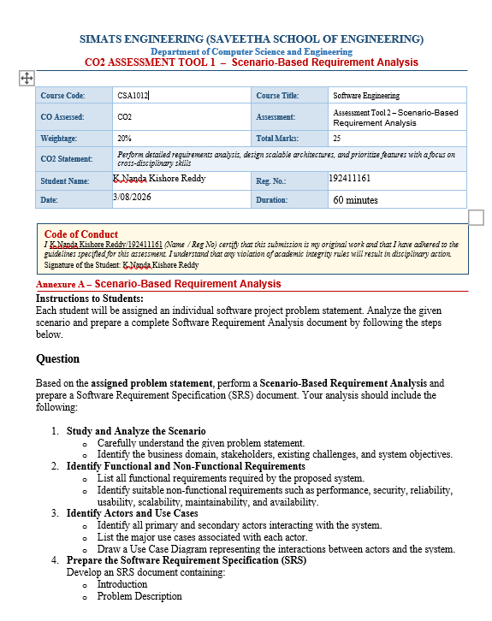
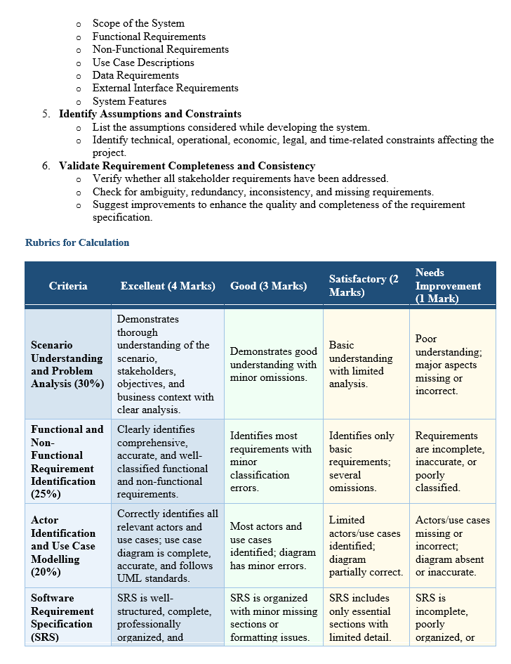
Table of Contents (Index)
Chapter No. | Title / Contents | Page No.
- | Cover Page | i
- | Certificate | ii
- | Acknowledgement | iii
- | Abstract | iv
- | Table of Contents | v
- | List of Figures | vi
- | List of Tables | vii
1 | Study and Analyse the Scenario | 1
1.1 | Business Domain | 1
1.2 | Problem Statement | 2
1.3 | Stakeholders | 3
1.4 | Existing Challenges | 4
1.5 | System Objectives | 5
2 | Functional and Non-Functional Requirements | 6
2.1 | Functional Requirements | 6
2.2 | Non-Functional Requirements | 10
3 | Actors and Use Cases | 12
3.1 | Primary Actors | 12
3.2 | Secondary Actors | 13
3.3 | Use Cases by Actor | 14
3.4 | Use Case Diagram (Text Representation) | 17
4 | Software Requirement Specification (SRS) | 18
4.1 | Introduction | 18
4.2 | Problem Description | 19
4.3 | Scope of the System | 20
4.4 | Functional Requirements | 21
4.5 | Non-Functional Requirements | 23
4.6 | Use Case Descriptions | 24
4.7 | Data Requirements | 27
4.8 | External Interface Requirements | 28
4.9 | System Features | 30
5 | Assumptions and Constraints | 32
5.1 | Assumptions | 32
5.2 | Constraints | 33
6 | Requirement Completeness and Consistency Validation | 35
6.1 | Stakeholder Requirement Coverage | 35
6.2 | Validation Checks | 36
6.3 | Missing Requirements | 37
6.4 | Conclusion | 38
7 | References | 39

1. Study and Analyse the Scenario
1.1 Business Domain
The system belongs to the Aviation and Airport Management domain. It focuses on baggage handling, tracking, logistics, and passenger services.
1.2 Problem Statement
Airports handle thousands of baggage items daily. Traditional baggage handling systems often face problems such as:
- Lost or misplaced baggage
- Delayed baggage delivery
- Incorrect baggage routing
- Lack of real-time tracking
- Poor communication between airlines and passengers
- Manual baggage management errors
These issues reduce customer satisfaction and increase operational costs.

1.3 Stakeholders
Primary Stakeholders
- Passengers
- Airport Authority
- Airlines
- Baggage Handling Staff
Secondary Stakeholders
- Security Officers
- Customs Department
- IT Administrators
- Airport Management
- Maintenance Team
- Logistics Managers

1.4 Existing Challenges
- Manual baggage identification
- Human errors during loading/unloading
- Difficulty locating lost baggage
- Delayed baggage transfers
- Lack of centralized tracking
- Poor communication between departments
- Limited passenger visibility

1.5 System Objectives
The proposed system aims to:
- Track baggage in real time
- Reduce baggage loss
- Improve baggage routing accuracy
- Automate baggage handling
- Notify passengers about baggage status
- Improve airport operational efficiency
- Generate reports for management
- Enhance passenger satisfaction

2. Functional and Non-Functional Requirements
2.1 Functional Requirements
FR1 User Authentication
- User login
- Logout
- Password management
- Multi-factor authentication

FR2 Passenger Management
- Passenger registration
- Passenger profile management
- View baggage details
- Receive baggage notifications

FR3 Flight Management
- Add flights
- Update flight schedules
- Cancel flights
- Assign baggage to flights

FR4 Baggage Registration
- Register baggage
- Generate baggage ID
- Print baggage tag
- Associate baggage with passenger

FR5 RFID/Barcode Tracking
- Scan baggage
- Update current location
- Record movement history
- Detect misplaced baggage

FR6 Baggage Routing
- Assign conveyor routes
- Update routing
- Detect routing errors
- Auto reroute baggage

FR7 Real-Time Tracking
- Live baggage location
- Expected arrival time
- Baggage status updates

FR8 Alerts and Notifications
- Boarding reminders
- Baggage loaded
- Baggage unloaded
- Baggage delayed
- Lost baggage alerts

FR9 Lost and Found Management
- Report lost baggage
- Search baggage database
- Match found baggage
- Notify passenger

FR10 Security Screening
- Record screening results
- Flag suspicious baggage
- Hold baggage
- Release baggage

FR11 Reporting
Generate reports for:
- Delayed baggage
- Lost baggage
- Daily baggage statistics
- Employee performance
- Flight baggage load
- Security reports

FR12 Administration
- Manage users
- Assign roles
- Configure system
- Backup database
- Monitor system

2.2 Non-Functional Requirements
Performance
- System response time < 2 seconds
- Support 50,000 baggage records/day
- Support 2,000 concurrent users
Security
- Encrypted communication
- Role-based access control
- Multi-factor authentication
- Secure database
Reliability
- 99.9% uptime
- Automatic recovery
- Fault tolerance
Availability
- 24×7 operation
- Backup servers
- Disaster recovery
Scalability
- Support multiple airports
- Handle increasing passenger traffic
Usability
- Easy-to-use interface
- Mobile-friendly design
- Multilingual support
Maintainability
- Modular architecture
- Easy software updates
- Logging and monitoring
Portability
- Web-based
- Mobile application
- Cloud deployment

3. Actors and Use Cases
Primary Actors
- Passenger
- Airline Staff
- Baggage Handler
- Airport Administrator

Secondary Actors
- Security Officer
- Customs Officer
- Logistics Manager
- System Administrator
- RFID Scanner
- Flight Information System

Use Cases by Actor
Passenger
- Register account
- Login
- Track baggage
- Receive notifications
- Report lost baggage
- View baggage history

Airline Staff
- Register baggage
- Assign baggage
- Update baggage status
- Manage flights

Baggage Handler
- Scan baggage
- Update baggage location
- Load baggage
- Unload baggage
- Transfer baggage

Security Officer
- Screen baggage
- Hold baggage
- Release baggage
- Report suspicious baggage

Airport Administrator
- Manage users
- Generate reports
- Configure system
- Monitor operations

Logistics Manager
- Monitor baggage flow
- Optimize routing
- Analyse reports

System Administrator
- Backup database
- Restore data
- Manage servers
- Security monitoring

Use Case Diagram (Text Representation)
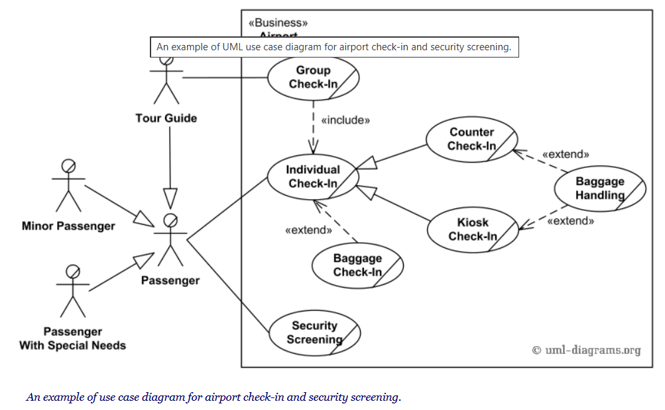

4. Software Requirement Specification (SRS)
4.1 Introduction
The Intelligent Airport Baggage Tracking and Logistics Management System is designed to automate baggage tracking and logistics operations using RFID/barcode technologies, real-time monitoring, and intelligent routing algorithms. The system minimizes baggage loss while improving operational efficiency and passenger satisfaction.

4.2 Problem Description
Current airport baggage handling systems suffer from:
- Lost baggage
- Delayed baggage
- Incorrect routing
- Manual processing
- Limited tracking
- Poor coordination
The proposed system provides real-time tracking and automated logistics management.

4.3 Scope of the System
The system includes:
- Passenger baggage registration
- RFID tracking
- Flight integration
- Real-time location updates
- Security screening
- Lost baggage management
- Notifications
- Reports
- Administrative management
The system excludes:
- Airline ticket booking
- Payment processing
- Cargo logistics unrelated to passenger baggage

4.4 Functional Requirements
ID | Requirement
FR1 | User authentication
FR2 | Passenger management
FR3 | Flight management
FR4 | Baggage registration
FR5 | RFID tracking
FR6 | Routing management
FR7 | Live tracking
FR8 | Notifications
FR9 | Lost baggage handling
FR10 | Security screening
FR11 | Reporting
FR12 | Administration

4.5 Non-Functional Requirements
Category | Requirement
Performance | Response <2 sec
Security | Encryption + MFA
Availability | 99.9% uptime
Reliability | Automatic recovery
Scalability | Multi-airport support
Maintainability | Modular design
Usability | User-friendly UI
Portability | Web & Mobile

4.6 Use Case Descriptions
UC1 Register Baggage
Actor: Airline Staff
Precondition
- Passenger has checked in.
Main Flow
- Scan passenger ticket.
- Enter baggage details.
- Generate RFID tag.
- Print baggage label.
- Store baggage record.
Postcondition
- Baggage is registered.

UC2 Track Baggage
Actor: Passenger
Precondition
- Baggage has been registered.
Main Flow
- Login.
- Enter baggage ID.
- System retrieves location.
- Display current status.
Postcondition
- Passenger views baggage location.

UC3 Report Lost Baggage
Actor: Passenger
Precondition
- Passenger cannot locate baggage.
Main Flow
- Submit complaint.
- System searches database.
- Notify baggage staff.
- Update passenger.
Postcondition
- Lost baggage case created.

4.7 Data Requirements
Passenger
- Passenger ID
- Name
- Passport Number
- Contact Number
- Email

Flight
- Flight Number
- Departure
- Destination
- Date
- Time

Baggage
- Baggage ID
- RFID Tag
- Weight
- Status
- Current Location

Employee
- Employee ID
- Name
- Role
- Department

Security Record
- Screening ID
- Result
- Officer Name
- Timestamp

4.8 External Interface Requirements
User Interface
- Web dashboard
- Mobile app
- Touchscreen kiosks

Hardware Interface
- RFID readers
- Barcode scanners
- Conveyor sensors
- Security scanners
- Printers

Software Interface
- Flight Information System
- Airline Reservation System
- Airport Database
- SMS Gateway
- Email Server
- Notification Service

Communication Interface
- HTTPS
- REST APIs
- Wi-Fi
- Ethernet
- Cloud Services

4.9 System Features
- RFID-enabled baggage tracking
- Barcode support
- AI-based route optimization
- Real-time notifications
- Lost baggage recovery
- Security integration
- Dashboard analytics
- Report generation
- Multi-airport support
- Cloud database
- Audit logs
- Backup and recovery

5. Assumptions and Constraints
Assumptions
- RFID tags are attached to all baggage.
- Airport network connectivity is reliable.
- Airlines provide accurate passenger and flight data.
- Users have authorized system access.
- Hardware devices are properly maintained.
- Flight information systems provide real-time updates.

Constraints
Technical Constraints
- Dependence on RFID/barcode infrastructure.
- Compatibility with existing airport systems.
- Limited network bandwidth during peak hours.
Operational Constraints
- Continuous 24×7 airport operations.
- Staff require training to use the system.
- Coordination among airlines, security, and baggage services.
Economic Constraints
- Budget limitations for RFID equipment and infrastructure.
- Ongoing maintenance and software licensing costs.
Legal Constraints
- Compliance with aviation regulations.
- Compliance with data privacy laws (e.g., GDPR or applicable local regulations).
- Secure handling of passenger information.
Time Constraints
- Project must be completed within the scheduled implementation timeline.
- Minimal disruption during deployment and migration.

6. Requirement Completeness and Consistency Validation
Stakeholder Requirement Coverage
Stakeholder | Requirements Addressed
Passenger | Tracking, notifications, lost baggage reporting
Airline Staff | Baggage registration, flight assignment
Baggage Handler | Scanning, routing, status updates
Security Officer | Screening, baggage hold/release
Airport Administrator | User management, reporting
Logistics Manager | Monitoring and route optimization
System Administrator | Backup, recovery, maintenance

Validation Checks
Ambiguity
- Functional requirements are defined with clear actions and outcomes.
- User roles and permissions are explicitly identified.
Redundancy
- Duplicate tracking and reporting functions have been consolidated.
Consistency
- Use cases align with functional requirements.
- Data entities support all required operations.
- Actors interact only with relevant system functions.
Missing Requirements
Recommended additions include:
- Predictive analytics for baggage delay detection.
- Offline synchronization for handheld scanners.
- API integration with airline mobile applications.
- Multi-language passenger notifications.
- Accessibility features for users with disabilities.
- Environmental monitoring (e.g., temperature-sensitive baggage).

Conclusion
The proposed Intelligent Airport Baggage Tracking and Logistics Management System addresses key challenges in airport baggage handling by providing automated registration, RFID/barcode-based real-time tracking, intelligent routing, security integration, passenger notifications, and comprehensive reporting. The SRS defines functional and non-functional requirements, actors, use cases, data requirements, interfaces, assumptions, constraints, and validation measures, providing a solid foundation for system design, implementation, testing, and deployment.
References
1. Sommerville, I., Software Engineering, 10th ed. Boston, MA, USA: Pearson, 2016.
2. Pressman, R. S., and Maxim, B. R., Software Engineering: A Practitioner's Approach, 9th ed. New York, NY, USA: McGraw-Hill, 2020.
3. Booch, G., Rumbaugh, J., and Jacobson, I., The Unified Modelling Language User Guide, 2nd ed. Boston, MA, USA: Addison-Wesley, 2005.
4. Object Management Group (OMG), Unified Modelling Language (UML), Version 2.5.1, Dec. 2017.
5. International Air Transport Association (IATA), Resolution 753: Baggage Tracking. Montreal, Canada: IATA.
6. International Civil Aviation Organization (ICAO), Annex 17 – Security: Safeguarding International Civil Aviation Against Acts of Unlawful Interference, ICAO.
7. ISO/IEC/IEEE 12207:2017, Systems and Software Engineering—Software Life Cycle Processes, ISO, Geneva, Switzerland, 2017.
8. ISO/IEC 25010:2011, Systems and Software Engineering—Systems and Software Quality Requirements and Evaluation (Square): System and Software Quality Models, ISO, Geneva, Switzerland, 2011.

